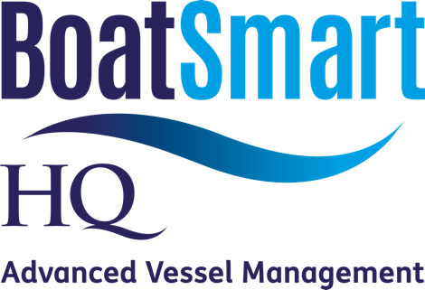

PRICING SCHEDULE

MONTHLY SUBSCRIPTION TIERS

 |  | Up to 10m | 10-15m | 15m+
BASIC: |  | $100 | $150 | $200
4 x VIR* each valued at: |  | $300 | $450 | $600
Cost per Annum |  | $1,200 | $1,800 | $2,400
PROFESSIONAL: |  | $137.50 | $212.50 | $275
6 x VIR* each valued at: |  | $275 | $425 | $550
Cost per Annum |  | $1,650 | $2,550 | $3,300
PREMIUM: |  | $250 | $400 | $500
12 x VIR* each valued at: |  | $250 | $400 | $500
Cost per Annum |  | $3,000 | $4,800 | $6,000
Dry Stack |  | 10m Pricing
Broker Aftercare Packages |  | 20% Discount or Custom Quote


*VIR (Vessel Inspection Report)

